Example title
John Smith¹, Mallu Mainio² and Taisto Tutkija^{1,2}
1 Optics Laboratory, University of Helsinki, Helsinki, Finland
2 Optoelectronics Department, Royal Institute of Technology, Stockholm, Sweden
Contact: mallu.mainio@helsinki.fi
Keywords: diffractive optics, micro lithography, nanostructures
This paragraph starts the text section of the abstract. The text is based on the Times New Roman font type using size 11 pt. The authors are kindly asked not to change the style definitions in the template. All authors must be listed in the submission system and an identical list must be presented in the abstract author list above. All authors email address must be typed in the submission system while submitting the paper but only the presenting author email address should be listed in the abstract contact section above. MAXIMUM LENGTH is ONE PAGE. This helps the organizers to assemble the proceedings by using these similarly typeset pages.
Start with a short introduction with possibly some references to relevant publications [1–3]. This helps the possibly unfamiliar reader to see the relevance of your research [1, 3]. Next clarify the aspects and ideas of the subject to be presented in oral speech/poster. A few illustrative figures or tables are a clear benefit. The use of black/white or clear grayscale/raster techniques in formatting the figures is preferred.
Please add one to four keywords of the subject before the text section. These will be used for index purposes. One possibility to find the proper keywords is to use the Optics Classification and Indexing Scheme (OCIS), which can be found in http://www.osa.org/pubs/authors/ocis/. Please limit keywords to one line.
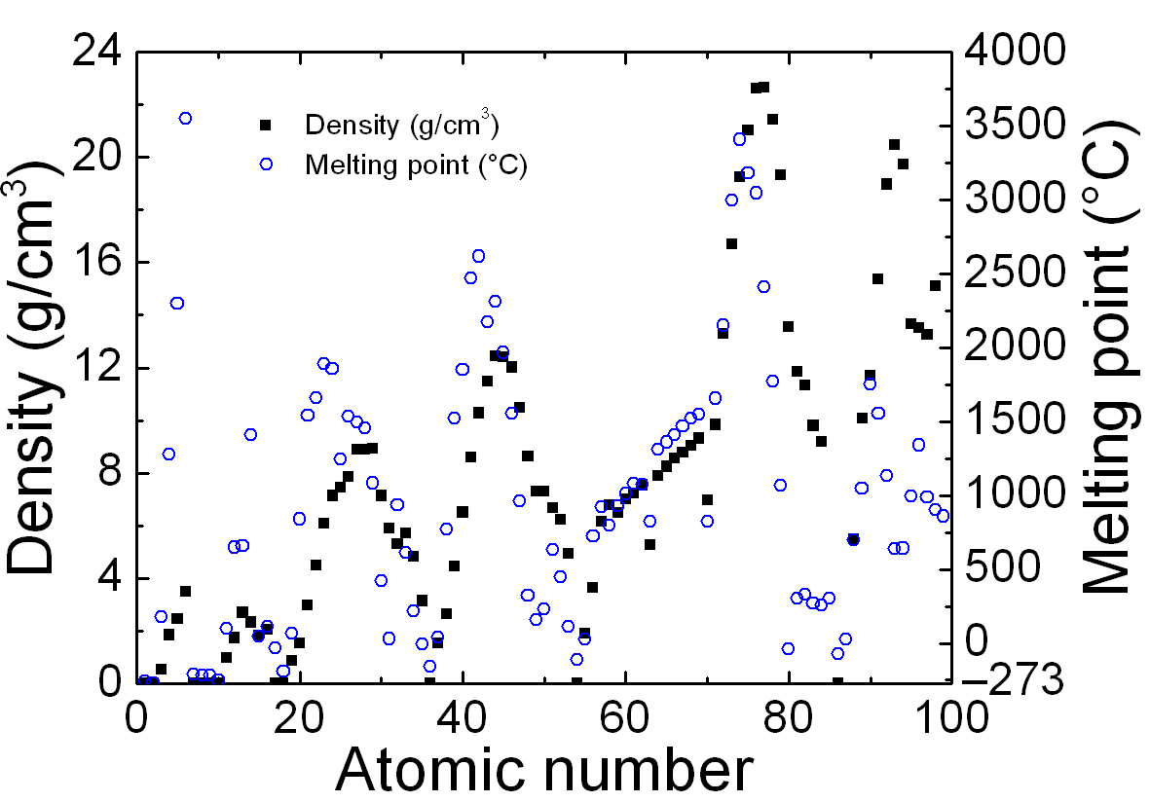
Simple Picture- of Metafile-formats can be used for embedded figure objects. Bitmaps can be used, too, but if possible, file size should be limited to less than 1Mb. EPS-files are naturally employed with LaTeX-formatting. If picture contain text, avoid JPG, prefer PNG, after pdf-conversion test yourself how the figures and tables print out on paper. This way your work will be more appreciated by future readers. Maximum converted pdf-file size should be below 10 MB.
 | Colhd1 | Header2 | Colhd3
Rowhd1 | 3.0 | 5.945 | 45 %
Rowhd2 | 3.5 | 5.946 | -
Rowhd3 | 3.9 | 3.947 | 48 %
More data | 4.8 | 5.879 | 81 %
Evan more data | 5.1 | 9.899 | 95 %

Table 1: Small sample table Fig. 1: Example plot of some data. Remember Physical quantity and unit to all axis.
To summarize, the preferred way to construct the abstract is to
1. use the provided template in MS Word or LaTeX,
2. replace the text and other items with the real text and figures,
3. save the original file, and then convert the file to PDF-format.
Last, it is good to give concise conclusions and maybe indicate plans for the future research. Make sure that your abstract fits to one page after pdf-conversion and that figures print out nicely. Submission system will not accept files larger than 10 MB. Test print, proof read, check hyphens, dashes, spaces, figures, formatting!
1. M. Mainio, J. Juonio, “Article title,” Optics Publication 12, pp. 123–129, 1998
2. O.P. Guru, E. Stein, “Book name” (Some Publisher Press, 1996)
3. Article or page name, available at www.opticslab.unicity/research/thesubject.html, cited on 2016-01-15

